https://landsurveyingservices.com <---menu --- change color after scrolling down

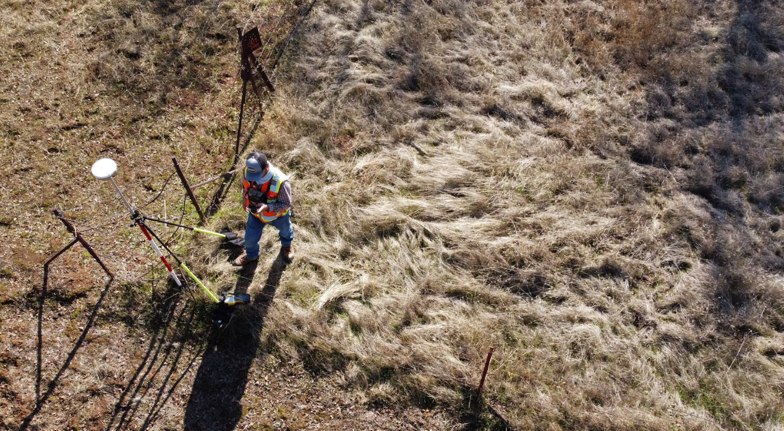

https://unsplash.com/photos/SVvYvR0HKhg

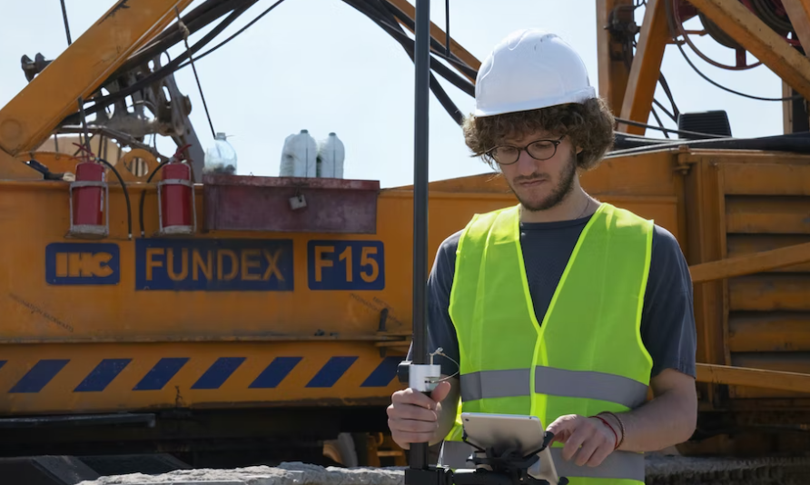

https://unsplash.com/photos/4QzsYY-7lKo

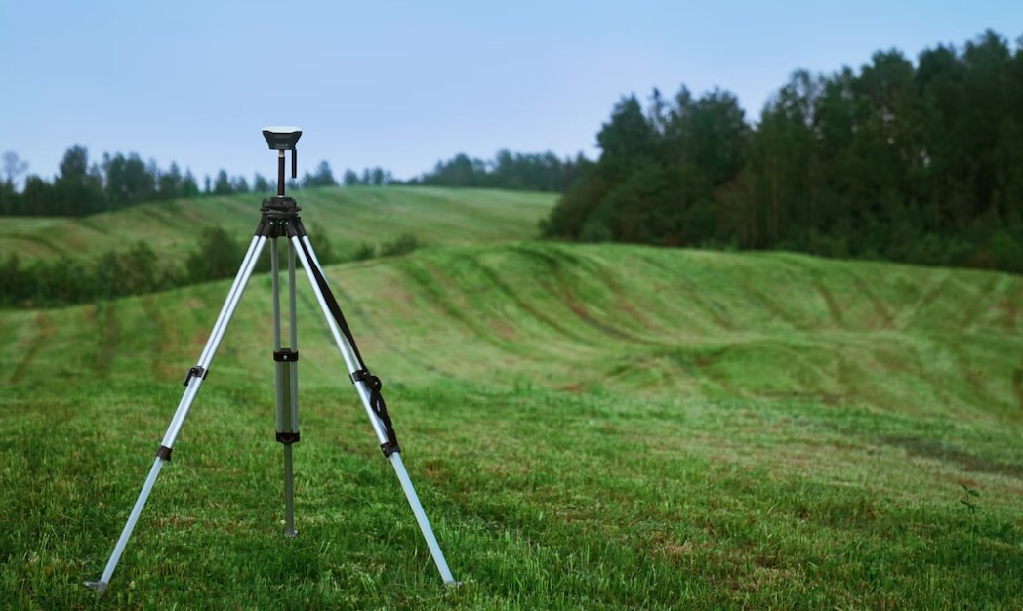

https://unsplash.com/photos/zSrksQgp4W0

https://pixabay.com/pl/photos/topografia-ankieta-tachimetr-813844/

__________________________________________________________________________________



__________________________________________________________________________________

https://geodetawojtek.pl/home/

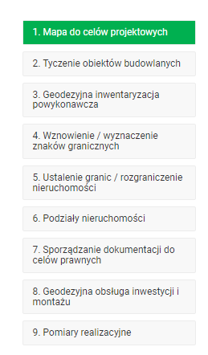

https://www.altasouthwest.com



https://wginc.com/services/planning/



_________________________________________________________________________________

https://www.psisurvey.com







